## **Publish web deployment package to IIS:**

### Press window+R key\click on start type Run to open Run window.

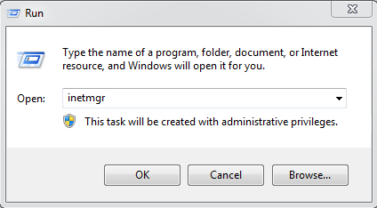

### In Run window enter **inetmgr** & press enter, it will open IIS

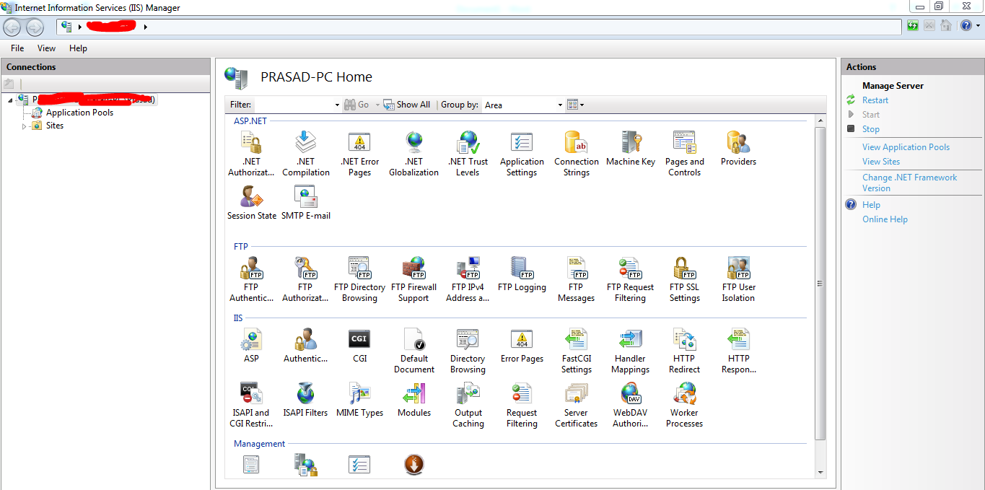

### Right click on Sites & select Add Website

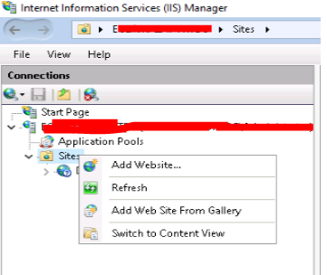

### Enter Site name & select physical path (Folder path where API will be deployed) click ok, New web site will be created in IIS. If 80 port is not in use then we can use it otherwise we can use any other port, just need to enter port number i.e 90, 88 etc

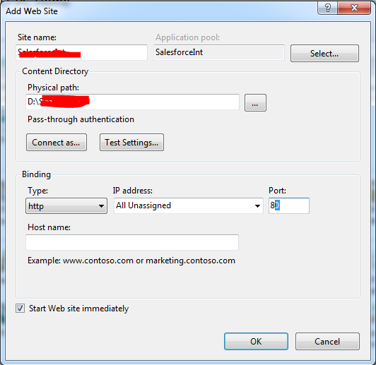

### Right click on newly created website and click on => Deploy => Import Application

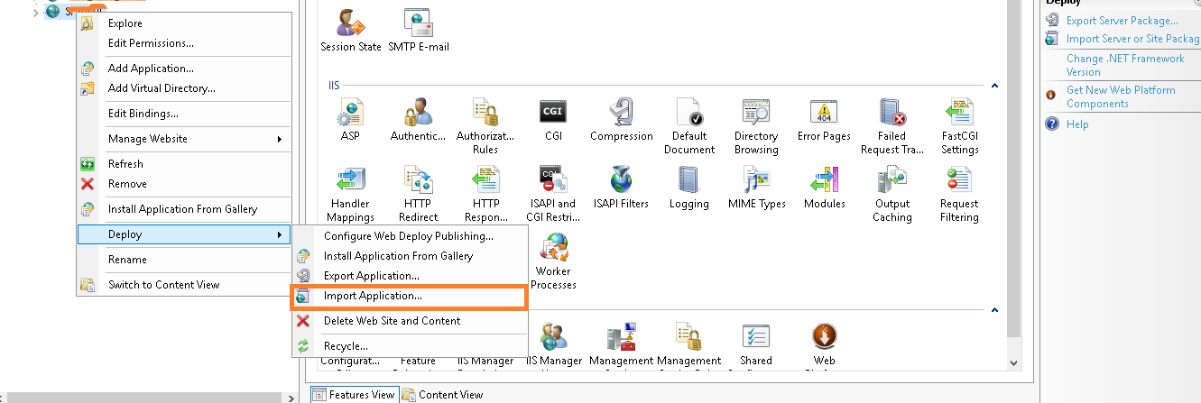

### Select the folder path where you have **SFSPFileManagement.zip** file and click on Next button.

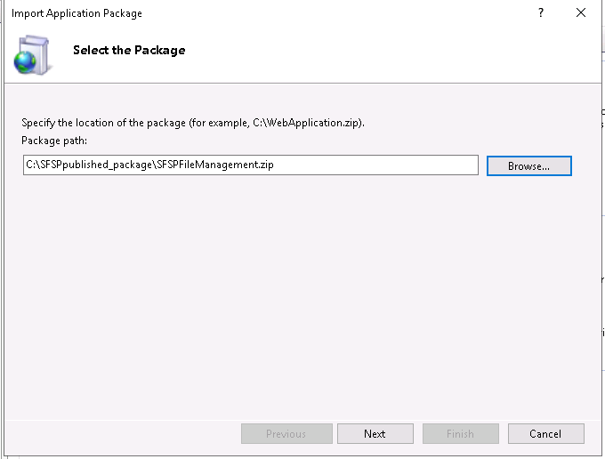

### Select all contents of the package and click on Next.

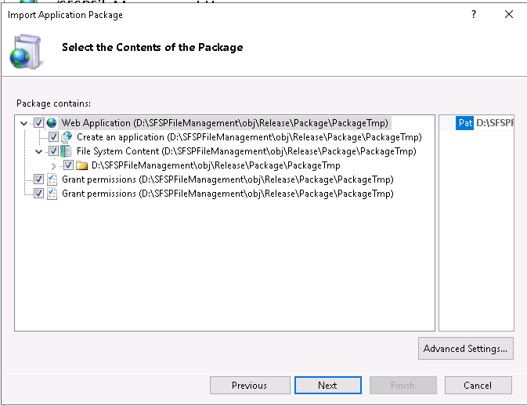

### Enter all parameters value will be populated from parameter.xml file if default values set to parameters.

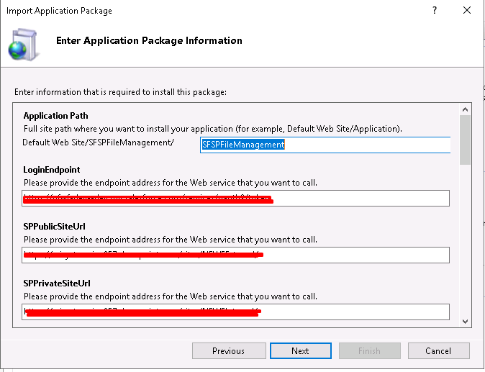

### It will deploy application in IIS.

